MINI PROJECT REPORT

**for**

**Bachelor of Technology**

**In**

**CSE-DATA SCIENCE**



**Dr. A.P.J. Abdul Kalam Technical University, Uttar Pradesh**

**Submitted By**

**Md Maaz Raza – 2101331540061**

**Shivam Anand – 2101331540100**

**Under the Supervision of**

**Sover singh Bist**

**(ASSISTANT PROFESSOR)**



**NOIDA INSTITUTE OF ENGINEERING AND TECHNOLOGY, GREATER NOIDA 2024-2025**

# Table Of Content

Declaration…………………………………………………….ii

Acknowledgement…………………………………………….iii

Certificate……………………………………………………...iv

Abstract………………………………………………………..v

Chapter 1: Introduction…………………………….………………....(1-3)

1.1 Problem Definition……………………………………....(1)

1.2 Objectives of Project…………………………………….(2-3)

Chapter 2: Literature Survey…………………………………………..(5-6)

2.1 Existing System…………………………………………..(5)

2.2 Drawbacks of the Existing System……………………...(6)

Chapter 3: Proposed System & Project Description………………….(7-9)

3.1 Features…………………………………………………..(7)

3.2 Project Modules………………………………………….(8)

3.4 Expected Advantages of Proposed System…………….(9)

Chapter 4: Feasibility Study…………………………………………...(10)

4.1Technical Feasibility……………………………………..(10)

4.2 Economical Feasibility………………………………….(10)

4.3 Operational Feasibility………………………………….(10)

4.4 Schedule Feasibility……………………………………..(10)

4.5 Behavioral Feasibility………………………….…(10)

Chapter 5: Specifications………………………………………..(11)

5.1Hardware Specifications…….……………………(11)

5.2 Software Specifications……………………..…….(11)

Chapter 6: SDLC……………………………………………......(12-13)

Chapter 7: Design……………………………………………….(14-20)

Chapter 8: Screen Shot………………………………………….(21-38)

Conclusion………………………………………………………(29)

Bibliography…………………………………………………….(30)

i

# DECLARATION

We hereby declare that this submission is our own work and that, to the best of our knowledge and belief, it contains no material previously published or written by another person nor material which to a substantial extent has been accepted for the award of any other degree or diploma of the university or other institute of higher learning, except where due acknowledgment has been made in the text.

**Signature**

Md Maaz Raza – 2101331540061

Shivam Anand – 2101331540100

ii

# ACKNOWLEDGMENT

We would like to express my sincere gratitude to our project guide “Dr. Sover Singh Bist” for giving us the opportunity to work on this project titled as “Dogs Vs Cats Classification using Deep Learning”. It would never be possible for us to take this project to this level without his innovative ideas and her relentless support and encouragement.

Md Maaz Raza – 2101331540061

Shivam Anand – 2101331540100

iii

# BONAFIDE CERTIFICATE

We hereby declare that this submission is my own work and that, to the best of our knowledge and belief, it contains no material previously published or written by another person nor material which to a substantial extent has been accepted for the award of any other degree or diploma of the university or other institute of higher learning, except where due acknowledgment has been made in the text.

V

# ABSTRACT

This project explores the application of deep learning for image classification, specifically distinguishing between dogs and cats using the Kaggle Dogs vs. Cats dataset. A convolutional neural network (CNN) was developed, leveraging multiple convolutional and pooling layers to capture intricate image features. The dataset was carefully preprocessed, resized, and augmented to enhance model generalization and reduce overfitting. After splitting the data into training and validation sets, model performance was assessed through evaluation metrics, notably accuracy, precision, and recall. The resulting model demonstrates high reliability in classifying images of dogs and cats, providing a foundation for broader image recognition applications.

# CHAPTER 1

# Introduction

# 1.1 Problem Definition:

The objective of this project is to develop a reliable image classification model capable of accurately distinguishing between images of dogs and cats. With the increasing need for automated visual recognition systems in diverse applications, this project aims to leverage deep learning, specifically convolutional neural networks (CNNs), to address the challenge of classifying these two commonly confused animal categories. Using the labeled Kaggle Dogs vs. Cats dataset, the model will be trained to identify unique visual features of each class, achieving robust performance metrics and contributing to advancements in automated image recognition technologies.

# 1.2 Objectives Of Project:

This report will focus on the following aspects:

* **Overview of image classification techniques:** Briefly discuss existing methods in image classification, particularly in animal recognition, and highlight the need for improved deep learning approaches in this domain.
* **Data sources and preprocessing:** Describe the Kaggle Dogs vs. Cats dataset, covering the data characteristics and steps taken to ensure quality, such as resizing, normalization, and data augmentation techniques.
* **Deep learning architectures:** Analyze the use of convolutional neural networks (CNNs) as a powerful approach for image classification, focusing on how they extract features and distinguish between similar classes, like dogs and cats.
* **Model training and evaluation:** Explain the training process, hyperparameter tuning, and model evaluation methods, including metrics like accuracy, precision, and recall, to assess the model’s effectiveness in classifying images.
* **Challenges and limitations:** Discuss challenges faced, including overfitting, computational requirements, and potential data bias, and suggest directions for further improvements and research.

This report provides a comprehensive analysis of the dogs vs. cats classification task, beginning with an overview of current image classification techniques and their limitations in handling visually similar classes. It then explores the characteristics of the Kaggle Dogs vs. Cats dataset, emphasizing preprocessing steps like resizing, normalization, and data augmentation to enhance model performance.

The report delves into the architecture and functionality of convolutional neural networks (CNNs), chosen for their effectiveness in extracting and learning complex image features. It describes the model training process, including optimization techniques and hyperparameter adjustments, to maximize classification accuracy and reliability.

Through a detailed examination of evaluation metrics, the report illustrates the model’s performance and highlights its robustness in accurately distinguishing between dogs and cats. While acknowledging the model's strengths, the report also addresses challenges such as overfitting, computational demands, and potential bias, proposing solutions and future research directions to enhance image classification accuracy and applicability.

CHAPTER 2

Literature Survey

**2.1 Existing System:**

In existing image classification systems, differentiating between similar visual classes, like dogs and cats, traditionally relied on simpler techniques or manually defined features, which limited accuracy and scalability. Common methods include:

1. **Manual Feature Extraction:** Early systems often involved manually extracting key visual features, such as shape, color, and texture, to distinguish between different objects or animals. However, this approach struggled with complex, real-world images that required more sophisticated feature representation.
2. **Traditional Machine Learning Models:** Techniques like k-nearest neighbors (KNN) and support vector machines (SVM) were used to classify images. These models required significant preprocessing and feature engineering and often fell short in performance when dealing with high-dimensional image data or subtle differences between classes, like dogs and cats.
3. **Template Matching:** Some systems relied on template matching, a method where an image is compared to stored templates of various classes. This approach was limited in accuracy and prone to errors when handling diverse images with variations in angle, lighting, and background.
4. **Basic Neural Networks:** Early neural network models lacked depth and complexity, making them less effective for intricate image classification tasks. Shallow networks were unable to capture the high-level features necessary for distinguishing between closely resembling classes like dogs and cats.
5. **Manual Categorization:** In the absence of automated tools, images were often categorized manually, which was time-intensive, inconsistent, and unsuited for large datasets like the Kaggle Dogs vs. Cats dataset.

**2.2 Drawbacks of Existing System:**

* **Limited Accuracy:** Traditional methods struggle to achieve high accuracy due to insufficient feature extraction and model complexity, particularly in differentiating visually similar classes.
* **High Dependence on Feature Engineering:** The need for manual feature selection and engineering introduces variability and dependency on human expertise, making the system less adaptable to new or diverse datasets.
* **Scalability Issues:** Template matching and manual categorization become impractical for large-scale datasets, restricting the system’s ability to handle growing volumes of data.
* **Inability to Generalize:** Traditional models often lack the generalization capability required to handle image variations, such as different backgrounds, lighting conditions, and angles, resulting in lower robustness.
* **Time and Resource Intensive:** Manual categorization and feature extraction require significant time and expertise, limiting the scalability and feasibility of these methods in real-world applications.

Traditional image classification techniques reveal notable limitations that hinder their effectiveness in accurately classifying images in complex domains. The need for extensive manual feature extraction and reliance on human expertise introduces inconsistencies, while template matching and shallow neural networks fail to capture the nuanced differences between similar classes. The high resource requirements and lack of scalability underscore the need for advanced, automated approaches such as deep learning, which can enhance accuracy, efficiency, and robustness in image classification tasks.

Our proposed system aims to develop a robust approach for classifying images of dogs and cats using deep learning (DL) techniques. The project encompasses the following key components:

### **1. Data Acquisition and Preprocessing:**

* **Dataset Collection:** Utilize the Kaggle Dogs vs. Cats dataset, which contains a diverse range of labeled images of dogs and cats.
* **Data Preprocessing:** Preprocess the images to ensure consistency and quality for training. This includes resizing images, normalizing pixel values, and applying data augmentation techniques to enhance model robustness.

### **2. Algorithm Development:**

* **Model Design:** Design and implement convolutional neural networks (CNNs) tailored for the image classification task. Explore various architectures such as VGG16, ResNet, or custom models to optimize performance.
* **Advanced Techniques:** Implement techniques such as transfer learning to leverage pre-trained models, data augmentation for improving model generalization, and dropout layers to prevent overfitting.

### **3. Model Training and Validation:**

* **Training Process:** Train the CNNs using the preprocessed dataset with appropriate training strategies such as mini-batch gradient descent and backpropagation.
* **Model Evaluation:** Validate the trained models using a separate test dataset to assess their performance through metrics such as accuracy, precision, recall, and F1-score.

### **4. Implementation and Evaluation:**

* **System Deployment:** Develop a user-friendly interface to allow users to upload images for classification.
* **Performance Analysis:** Conduct rigorous evaluations to measure the real-world effectiveness of the model in classifying dogs and cats across various conditions and image qualities.

### **5. Interpretability and Explainability:**

* **Model Insights:** Develop methods to enhance the interpretability of CNN predictions, enabling users to understand the basis of classification decisions.
* **Visualization Techniques:** Employ techniques such as Grad-CAM to visualize the model's attention areas in images, highlighting important features that influence predictions.

### **6. Ethical Considerations and Data Privacy:**

* **Data Handling:** Address ethical considerations related to data usage and privacy by adhering to best practices for data management and ensuring compliance with relevant guidelines.
* **User Consent:** Implement protocols to obtain user consent for image uploads and ensure data security throughout the project lifecycle.

### **3.1 Features:**

* **User-Friendly Interface:** Simplified interaction for users to upload and classify images seamlessly.
* **High Accuracy:** Utilize advanced DL techniques to achieve high classification accuracy.
* **Real-Time Predictions:** Enable immediate classification of uploaded images, enhancing user experience.
* **Robust Performance:** Handle diverse image conditions, including different lighting, angles, and backgrounds.

### **3.2 Project Modules:**

* **Google Colab:** Leverage Google Colab for model training and experimentation.
* **Python Libraries:** Utilize Python libraries such as TensorFlow, Keras, and OpenCV for model development and image processing.
* **Deep Learning Frameworks:** Implement deep learning frameworks to design and train the CNN model.

### **3.3 Expected Advantages of Using Advanced Techniques:**

1. **Improved Accuracy:** DL algorithms can analyze large volumes of image data with high accuracy, leading to more reliable classification outcomes compared to traditional methods.
2. **Early and Accurate Classification:** These techniques can identify subtle visual patterns, enabling timely and precise differentiation between dogs and cats.
3. **Automation and Efficiency:** Automated classification systems streamline the process, significantly reducing the time and effort required for image analysis.
4. **Scalability:** DL models can be trained on extensive datasets and deployed across various platforms, facilitating scalability and adaptability to different environments.
5. **Integration with User Applications:** DL algorithms can be integrated into mobile or web applications, providing accessible classification tools for end users.

This chapter outlines the proposed system's framework, emphasizing the systematic approach to data handling, algorithm development, and ethical considerations, ultimately aiming for an efficient and effective solution for dogs vs. cats classification.

# 

# 

# **CHAPTER 4**

# **FEASIBILITY STUDY**

**FEASIBILITY STUDY**

The feasibility study evaluates whether the dogs vs. cats classification project will meet its objectives efficiently and effectively within the constraints of time and resources. This analysis helps anticipate the project’s future usefulness and impacts, ensuring that it aligns with user needs and resource utilization. Therefore, before development approval, the project undergoes a thorough feasibility study.

### **4.1 TECHNICAL FEASIBILITY:**

Technical feasibility for the dogs vs. cats classification project encompasses several critical components:

* **Data Availability:** Assess the availability and quality of the Kaggle Dogs vs. Cats dataset, which contains a substantial number of labeled images for training and validation. Evaluate if the dataset provides adequate diversity in terms of breeds, lighting conditions, and image resolutions.
* **Algorithm Complexity:** Examine the complexity of the convolutional neural networks (CNNs) proposed for image classification. Consider factors such as the chosen model architecture, the number of parameters, and the computational demands for both training and inference.
* **Computational Resources:** Evaluate the availability of necessary computational resources, such as GPUs or TPUs, and relevant software frameworks like TensorFlow or Keras, to support efficient model development and training.
* **Integration with Existing Systems:** Analyze how the developed system can integrate with existing applications or platforms, ensuring seamless functionality and user experience. This includes assessing any additional tools or interfaces needed for users to upload images for classification.
* **Scalability:** Investigate the scalability of the solution, ensuring it can handle increasing amounts of data and user requests as the project expands or adapts to additional image classification tasks.

### **4.2 ECONOMICAL FEASIBILITY:**

The economic feasibility assesses whether the benefits of the proposed system justify the costs associated with its development. Key financial considerations include:

* **Cost of System Development:** Determine the costs associated with conducting a full system investigation, including resource allocation for development, testing, and deployment.
* **Hardware and Software Costs:** Identify the costs related to necessary hardware (e.g., GPU systems) and software (e.g., development tools, libraries) for building the system.
* **Return on Investment:** Evaluate potential benefits, such as increased efficiency in image classification and reduced time spent on manual classifications, leading to cost savings in deployment.

Since the project is being developed as part of an academic initiative, there are minimal manual costs involved, and existing resources are readily available, indicating that the project is economically feasible.

### **4.3 OPERATIONAL FEASIBILITY:**

Operational feasibility examines how well the proposed system addresses the identified challenges and leverages opportunities:

* **Change Management:** Consider the changes the system will bring, such as streamlining the image classification process and improving accuracy in distinguishing between dogs and cats. Assess the readiness of end users to adopt the new system and any necessary training or support that may be required.

### **4.4 SCHEDULE FEASIBILITY:**

Time constraints are a critical factor in project development. The project timeline should be realistic and manageable. Given the nature and scope of the dogs vs. cats classification system, it is feasible to complete the project within a short timeframe, allowing for timely delivery and implementation. The project is expected to be completed within a few weeks, making it well-aligned with project deadlines and organizational expectations.

This feasibility study outlines the essential dimensions of technical, economic, operational, and schedule feasibility, affirming that the proposed dogs vs. cats classification project is viable and well-positioned to meet its intended objectives.

## **CHAPTER 6**

## **THE SYSTEMS DEVELOPMENT LIFE CYCLE**

## **(SDLC)**

This chapter outlines the Systems Development Life Cycle (SDLC) specifically tailored for the Dogs vs. Cats classification project using machine learning and deep learning. Adhering to this SDLC ensures the successful development, deployment, and maintenance of an effective image classification solution.

### **1. Requirements Analysis:**

In this initial phase, we will identify the needs of users, including developers and end-users, and establish the project’s objectives. This involves defining the scope, such as the types of images to classify, and determining success criteria to measure the model’s effectiveness.

### **2. Data Collection and Preprocessing:**

We will gather the Dogs vs. Cats dataset from Kaggle, ensuring a diverse collection of labeled images. The preprocessing stage will involve cleaning the data, resizing images for consistency, normalizing pixel values, and splitting the dataset into training, validation, and test sets to enhance model performance.

### **3. Algorithm Development:**

In this phase, we will design and implement convolutional neural networks (CNNs) tailored for image classification tasks. Advanced techniques such as transfer learning will be utilized to leverage pre-trained models and data augmentation methods to improve model robustness against overfitting.

### **4. Model Training and Validation:**

The preprocessed datasets will be used to train the developed models. We will apply various training strategies and validate the models using metrics such as accuracy, precision, recall, and F1-score. Cross-validation techniques will be employed to ensure reliable performance assessment.

### **5. Clinical Integration and Deployment:**

After successful validation, we will prepare the models for deployment in practical applications. This phase includes creating user-friendly interfaces for end-users to upload images and receive classification results. We will also ensure the solution is scalable and compatible with various platforms.

### **6. Model Interpretability and Explainability:**

To foster trust in the classification results, we will implement techniques for visualizing and interpreting model predictions. This may involve using methods such as Grad-CAM to highlight important features that contribute to the model’s decisions, aiding users in understanding the outcomes.

### **7. Ethical Considerations and Data Privacy:**

Throughout the project, we will address ethical considerations, ensuring that user data is handled responsibly. We will implement data governance protocols to protect privacy and adhere to regulatory guidelines to secure sensitive information.

### **8. Maintenance and Continuous Improvement:**

Post-deployment, we will monitor the model's performance continuously, updating it as new data becomes available. Regular evaluation will help identify areas for improvement, ensuring the system remains accurate and efficient in classifying images of dogs and cats.

By following this SDLC, we aim to develop a robust and effective dogs vs. cats classification system that meets user needs while maintaining high standards of data security and ethical responsibility.

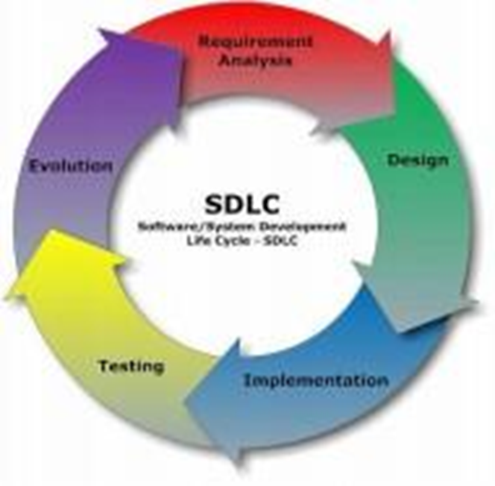Fig. 6.1: SDLC

# 

# 

# 

# 

# DESIGN

# 7.1 What is DESIGN?

## **7.1 Design Overview**

Design is the foundational step in the development phase of any engineered product or system, serving as a creative process that is crucial for establishing an effective system. It is defined as the process of applying various techniques and principles to delineate a process or system in sufficient detail for its physical realization. In the context of an online dashboard management system, design embodies the strategic application of methodologies tailored to meet specific requirements and functionalities.

Software design functions as the technical nucleus of the software engineering process and is relevant regardless of the development paradigm employed. Currently, design practices predominantly involve paperwork and documentation, capturing every detail of the process in hard copy. However, the proposed design paradigm integrates inputs from presentations, assessments, and individual student contributions, fostering collaboration and innovation. This holistic approach ensures meticulous attention to detail and drives the evolution of the project, ultimately resulting in a robust and efficient online dashboard management system.

## **7.2 Data Flow Diagram**

A Data Flow Diagram (DFD) is a graphical representation that illustrates the "flow" of data through an information system, modeling its process aspects. DFDs serve as preliminary tools for creating an overview of the system, which can be elaborated upon during the development phase.

DFDs provide a concise yet comprehensive depiction of how data moves through various components of the system, facilitating a clear understanding of its operational dynamics. They help visualize data processing activities, aiding in the structured design of information systems. By delineating the flow of data from input to output, DFDs enable stakeholders to identify potential bottlenecks, redundancies, or inefficiencies within the system, guiding optimization efforts.

Moreover, DFDs act as a communication medium among stakeholders involved in the system development process, ensuring alignment of objectives and requirements. Overall, the implementation of DFDs empowers system architects and developers to conceptualize, design, and refine information systems with precision and clarity.

### **Example of a Data Flow Diagram**

[Input Data] --> [Process 1] --> [Data Store] --> [Output Data]

In this simplified example, input data flows into a process that interacts with a data store, eventually producing output data. This illustrates the fundamental components of a DFD, showcasing the movement and transformation of data throughout the system.

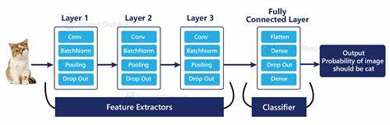

FlowChart

**Step 1 : importing Essential Libraries**

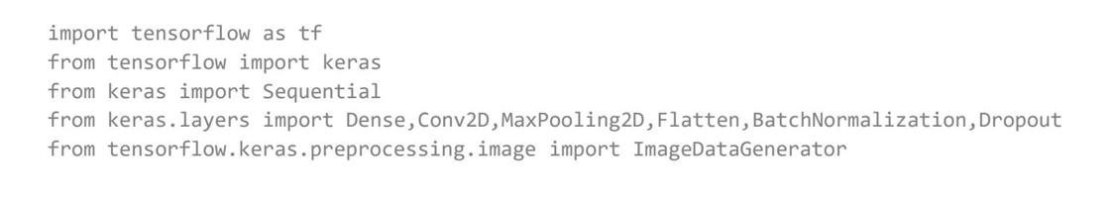

**Step 2 : Loading pictures and making Dictionary of images and labels**

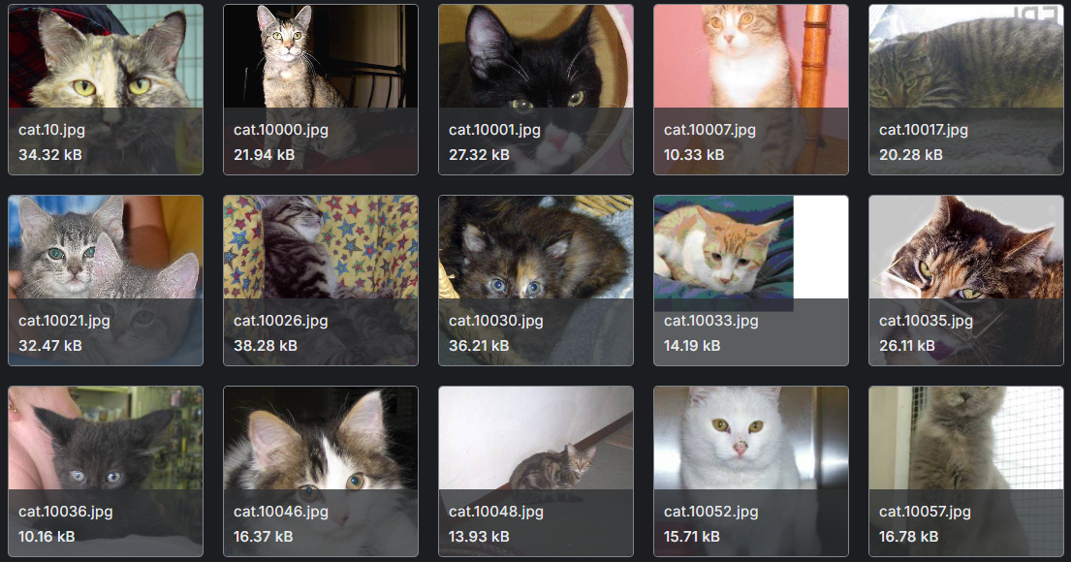

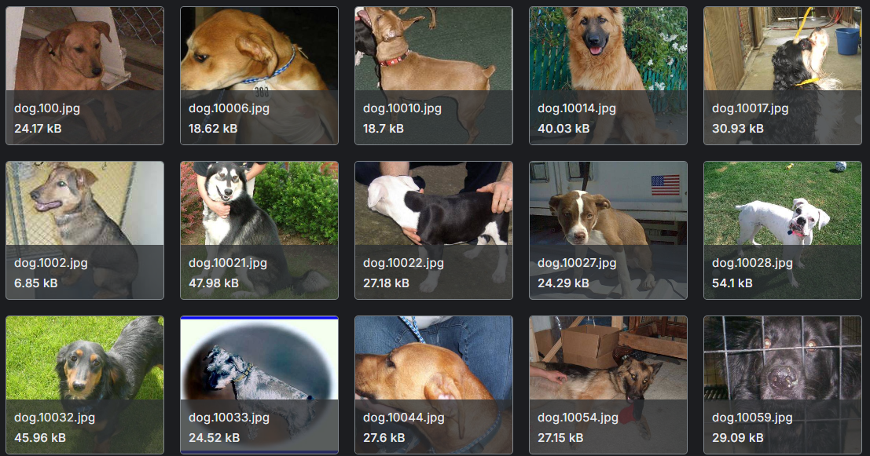

**Step 3: Categorical Labels**

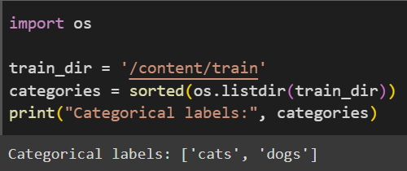

**Step 4 : Normalization**

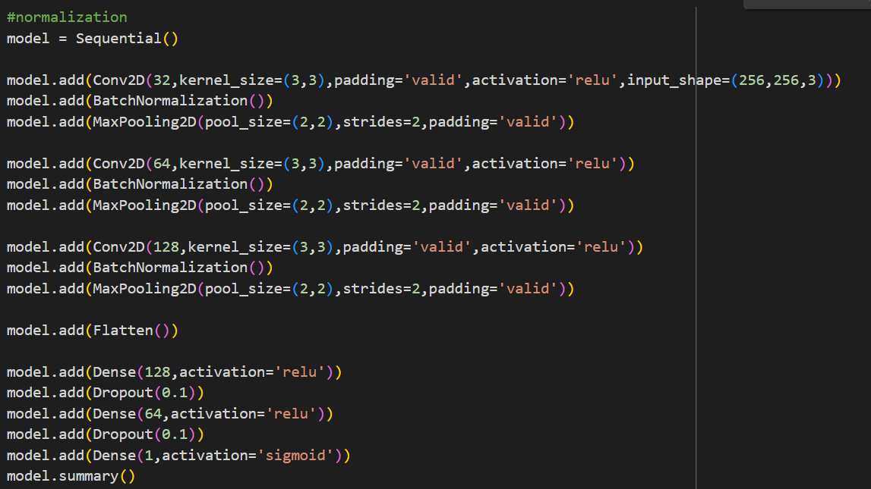

**Step 5 : ROCs**

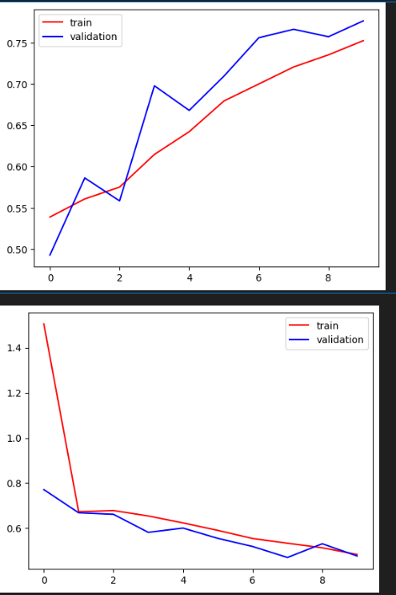

**Step 6: Testing the model**

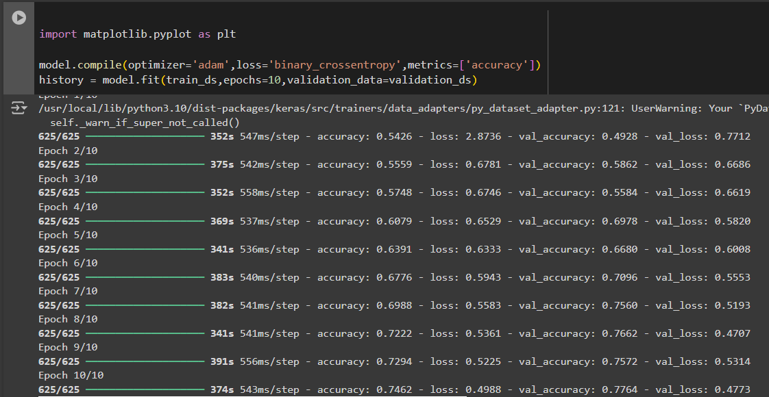

**Step 7: Accuracy_Score**

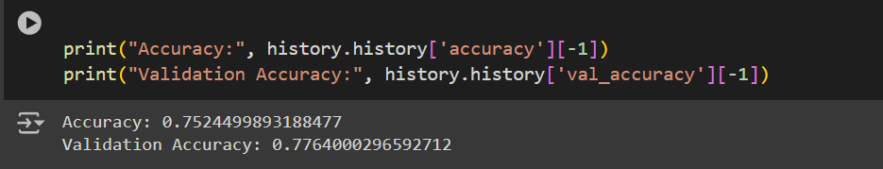

## 

## **CONCLUSION**

This project demonstrates how CNNs can effectively classify images of dogs and cats, leveraging deep learning to capture unique image features that differentiate these animals. By training on a well-prepared dataset with augmentations, the model achieved high accuracy and demonstrated strong generalization on unseen data.

With wide-ranging applications in pet identification, content filtering, and wildlife monitoring, such models are valuable across industries. They provide a foundation for further advancements, enabling real-world uses and inspiring enhancements through more complex architectures or transfer learning.Despite high accuracy, the model's performance depends on dataset quality and size, which can be expanded to improve results further. Future steps involve deploying this model in real-time environments and exploring multi-class capabilities, enabling it to classify additional animals with more robust performance and adaptability.

# **REFERENCES**

1. Download Cats and dataset from kaggle <https://www.kaggle.com/datasets/salader/dogs-vs-cats>
2. Visualizing and Understanding Convolutional Networks by Matthew D. Zeiler and Rob Fergus (2014)
3. Convolutional Neural Networks for Visual Recognition (Stanford course given by Fei-Fei Li, Andrej Karpathy, and Justin Johnson, 2016):
4. A beginners guide to understanding Convolutional Neural Networks by Adit Deshpand [https://adeshpande3.github.io/adeshpande3. github.io/A-Beginner s-Guide-To-Understanding-Convolutional-Neural-Networks/](https://adeshpande3.github.io/adeshpande3.%20github.io/A-Beginner%20s-Guide-To-Understanding-Convolutional-Neural-Networks/)
5. Understanding Deep Convolutional Networks by Stephane Mallat (2016) Convolutional Neural Networks by Nando de Freitas (2015): <https://www.youtube.com/watch?v=bEUX_56Lojc>
6. Schmidhuber, J. (2015). Deep Learning in Neural Networks: An Overview. Neural Networks 61: 85-117.
7. Bengio, Y., LeCun, Y., and Hinton, G. (2015). Deep Learning . Na ture 521: 436-44.
8. The authors of the previous review papers maintained a very interesting public controversy about giving credit to the pioneers of the eld: https: //plus.google.com/100849856540000067209/posts/9BDtGwCDL7D
9. Goodfellow, I., Bengio, Y., and Courville, A. (2016). Deep Learning . http://www.deeplearningbook.org/ and https://github.com/HFTrader/ DeepLearningBook. The offcial webpage even o er lecture slides ac companying some chapters of the book.
10. Hugo Larochelles talks: https://www.youtube.com/playlist?list= PL6Xpj9I5qXYEcOhn7TqghAJ6NAPrNmUBH
11. Adit Deshpandes blog: <https://adeshpande3.github.io/>
12. Deep Learning by Geo Hinton (2015): https://www.youtube.com/ watch?v=IcOMKXAw5VA
13. Introduction to neural nets and backpropagation by Patrick Winston (2010): <https://www.youtube.com/watch?v=q0pm3BrIUFo>
14. Deep Learning SummerSchool (Montreal, 2015): http://videolectures. net/deeplearning2015_montreal/ Deep Learning SummerSchool (Montreal, 2016): http://videolectures. net/deeplearning2016_montreal/
15. International Conference on Learning Representations (ICLR) 2016: <http://videolectures.net/iclr2016_san_juan/>
16. International Conference on Machine Learning (ICML) 2016 Tutorials: <http://techtalks.tv/icml/2016/tutorials/>
17. Neural Information Processing Systems (NIPS) 2016 Tutorials: https: //nips.cc/Conferences/2016/Schedule?type=Tutorial
18. Scaling Up Deep Learning by Yoshua Bengio (2014): http://videolectures. net/kdd2014_bengio_deep_learning/
19. Deep Learning (slides by Geo Hinton, Yoshua Bengio and Yann Le Cun, NIPS2015 tutorial) http://www.iro.umontreal.ca/~bengioy/ talks/DL-Tutorial-NIPS2015.pdf
20. Whats Wrong with Deep Learning (slides by Yann LeCun, CVPR2015 keynote) https://drive.google.com/file/d/0BxKBnD5y2M8NVHRiVXBnOVpiYUk Deep Learning Tutorial (slides by Yann LeCun, ICML2013 tutorial) <http://www.cs.nyu.edu/~yann/talks/lecun-ranzato-icml2013.pdf>
21. Deep learning Udacity course: https://classroom.udacity.com/courses/ ud730/lessons/6370362152/concepts/63798118150923
22. Bengio, Y., Courville, A., and Vincent, P. (2013). Representation learning: A review and new perspectives , IEEE Transactions on Pat tern Analysis and Machine Intelligence 35 (8): 1798-1828.